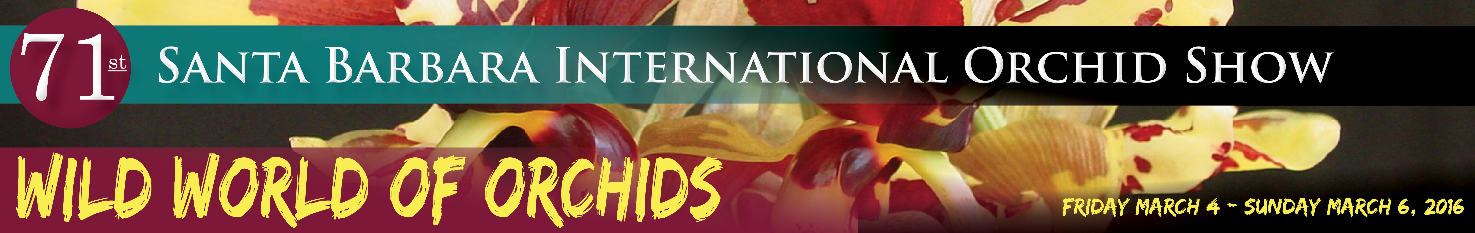
SB International Orchid Show honors renowned
orchid-grower Paul Gripp

SANTA BARBARA, CALIFORNIA (November 13, 2015) – The mind of Paul Gripp is part botanical catalogue, part horticultural instruction manual and part orchid-hunting adventure archive. Gripp, a spry Santa Barbara octogenarian and living legend in the orchid world, will be honored at the 2016 Santa Barbara International Orchid Show for his myriad contributions to the orchid industry.

Longtime former owner of the Santa Barbara Orchid Estate, Gripp has spent a lifetime under the spell of orchids. Over 60 years dedicated to discovering, growing and teaching others all about the fascinating flowers have earned Gripp the titles author, expert and authority on all things orchids.

The 71st annual SB International Orchid Show’s theme, “Wild World of Orchids,” pays homage to a family of flowering plants that are like an adopted family to Paul Gripp. His life’s work celebrated orchid beauty, unraveled their mystery, and infected countless people with orchid enthusiasm.

Gripp grew up in Topanga Canyon, but fate delivered him to Santa Barbara and landed him permanently and passionately in orchid growing when he was fresh out of the US Navy in 1957. Before that, while attending UCLA, Gripp had worked as a gardener for Robert J. Chrisman, orchid hobbyist and vice president of Farmers Insurance.

Chrisman bought five acres of land in Goleta, practically a stone’s throw from the ocean, and invited Gripp, then stationed in Tokyo, to help him open the SB Orchid Estate. Gripp agreed, bringing a UCLA degree in horticulture and botany into his new position as manager of the estate.

With Gripp’s patient persistence and willingness to traverse the globe in search of rare and wonderful orchids, the Orchid Estate became one of the world's foremost collectors and propagators of orchid species and hybrids. Orchid lovers around the nation came to recognize Gripp’s name and his entertaining way of presenting scientific material in his popular monthly column for the American Orchid Society Bulletin. Meanwhile, he cultivated an unrivaled collection of “outdoor” orchid species that thrive in the Southern California climate.

Ever eager to introduce the new and unusual, Gripp spent decades periodically roaming the world in search of unique species to bring home. He ventured regularly to far-flung locales like Central America, Brazil, the high Andes, India, Burma, New Guinea, and the Solomon Islands.

In 1967, Gripp purchased the SB Orchid Estate from Chrisman and ran it until he retired in 1986. Now Gripp’s two children, Parry and Alice, own the business.

Santa Barbara International Orchid Show is open Friday, March 4 through Sunday, March 6 from 9 a.m. to 5 p.m. daily at Earl Warren Showgrounds, located in Santa Barbara at Highway 101 and Las Positas Road. General admission is $12; seniors, students with ID and advance group sales (minimum 25) are $10; and children 12 and under are free with an adult. Tickets are available in advance at www.SBOrchidShow.com/.

